I&D Ocean Compliance Dashboard

**Technical Documentation**

**File Automation**

File automation uses technology to streamline file management tasks like creation, editing, and sharing **without manual effort**.

**Employee Master:**

Here, file automation ensures the latest file is automatically loaded into Power BI.

Here, the **latest data source file** in employee master data is automatically refreshed without any manual intervention.

**Employee GAD (Previous):**

Here, the **second latest data** **source file** in Employee GAD data is automatically refreshed without any manual intervention.

**I&D Ocean (Current):**

Here, the **latest data source file** in I&D Ocean data is automatically refreshed without any manual intervention.

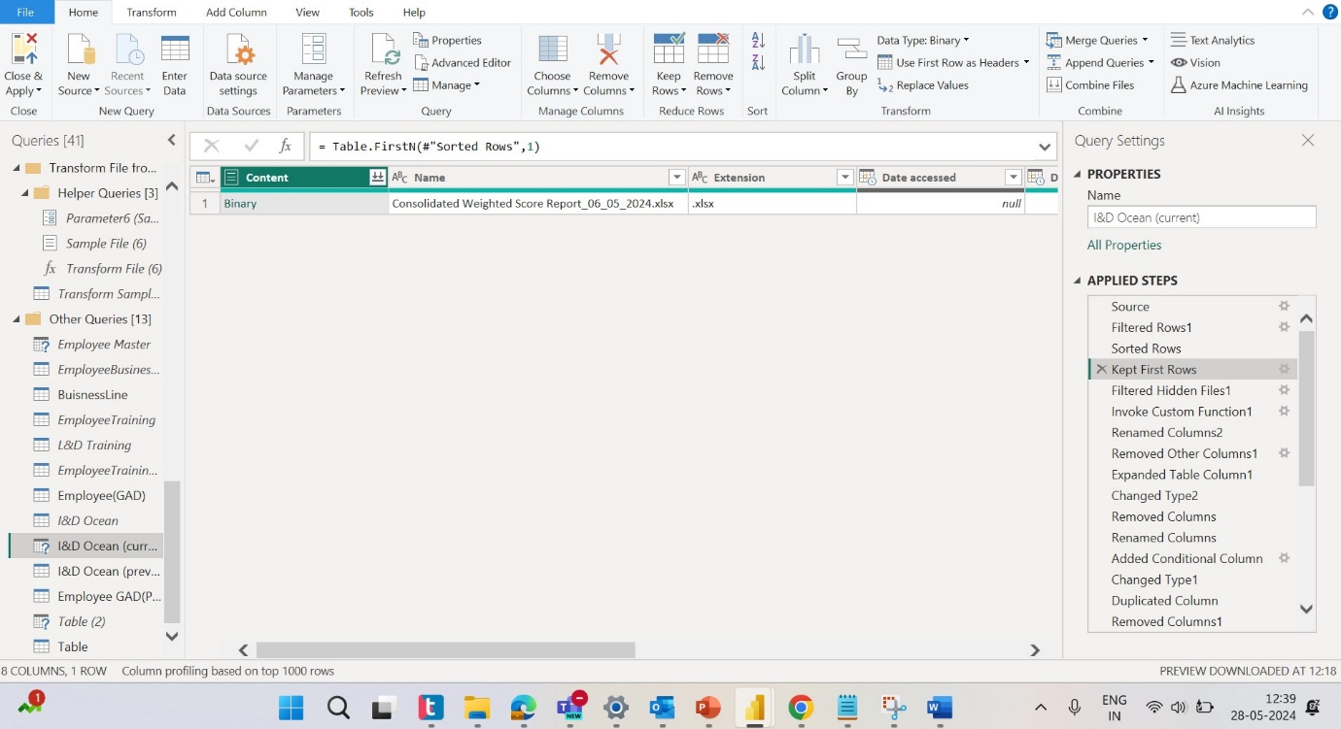

**Power Query editor changes in I&D Ocean (Current) source file**

**Renaming the columns:**

After updating the file, the column names have been renamed as follows:

* Global Employee Id is now Global Emp Id
* Local EmpId is now Employee Id (Local)
* UserId is now User Id (Login Id)
* Employee Email Address is now Capgemini Email Id
* Grade Details is now Grade (Details)
* SBU as per HR is now SBU
* Assessment Name is now Technology Assessment Name
* Attempt 1 Score is now Technology Score Attempt 1
* Attempt 2 Score is now Technology Score Attempt 2
* Highest Score is now Highest Technology Score
* No of Dimensions Attempted is now Assessment Attempted
* No of Dimensions Applicable is now Number of Assessments
* Overall Completion Status is now Assessment Status
* Dimensions Weighted Score is now Weighted Score
* Score Range is now Score Bucket
* Supervisor Email is now Supervisor Email address
* SkillSet is now Track
* Proficiency Level is now Proficiency level

These changes reflect the updated terminology in the file.

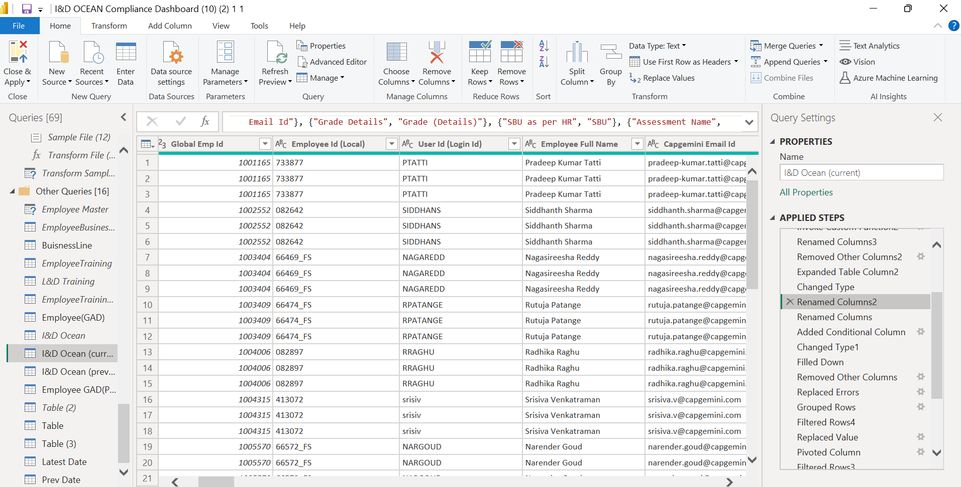

**Fill Down:**

After the column names are renamed, if needed can change **column names** also performed **Fill down operation** which allows you to fill blank or null values in a column with the value from the cell above.

The columns that have been filled down are: **Professional Community**, **Role Family**, **Role**, **Number of Assessments**, **Score Bucket**, **Assessment Status**, and **Record Status**.

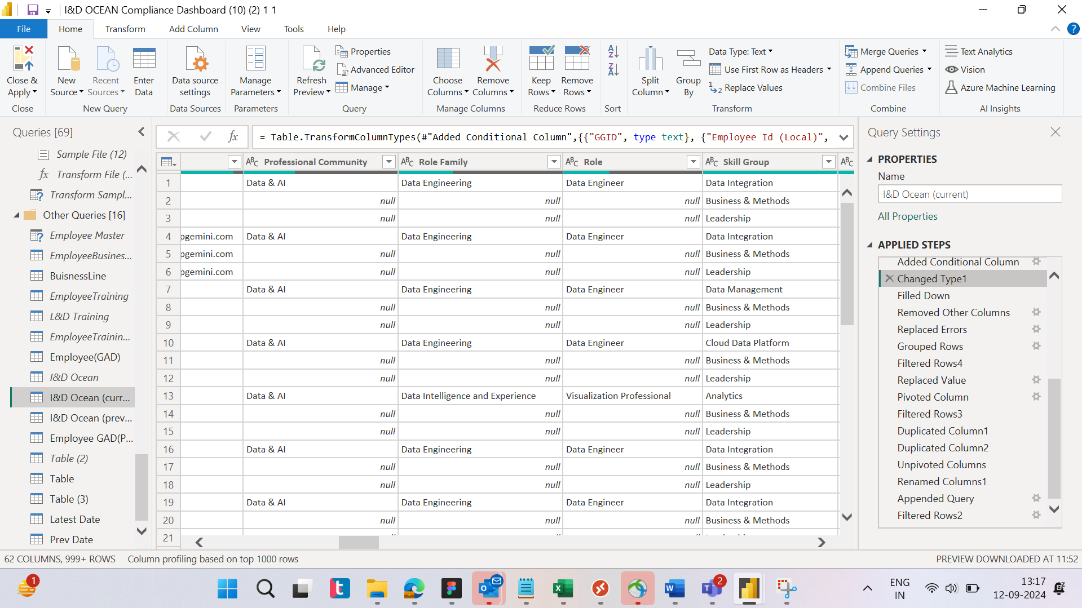

After Fill down operation the **null values will replace with the value of previous column**.

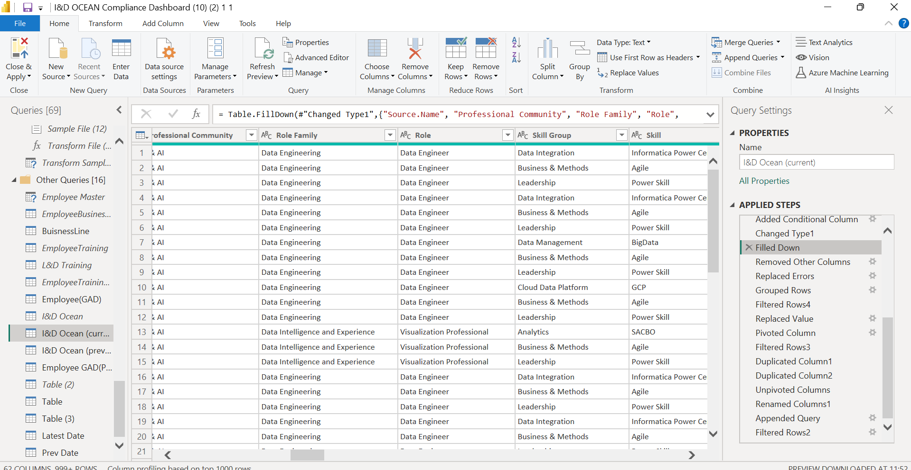

**Grouped rows:**

In the grouped row step, we have replaced the **Certified** column with the **Certification Status** column.

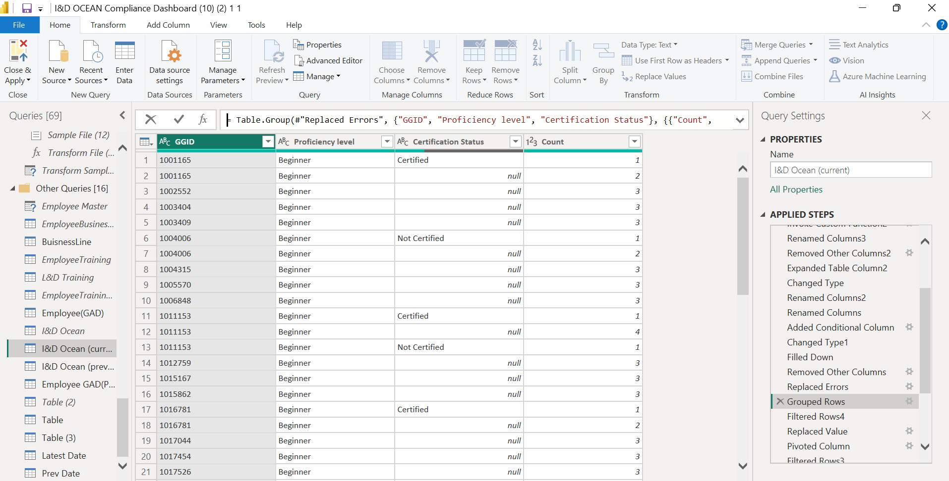

**I&D Ocean (Previous):**

Here, the **Second latest data** **source file** in I&D Ocean data is automatically refreshed without any manual intervention.

The changes made in I&D Ocean (current) should be applied similarly to I&D ocean (previous)

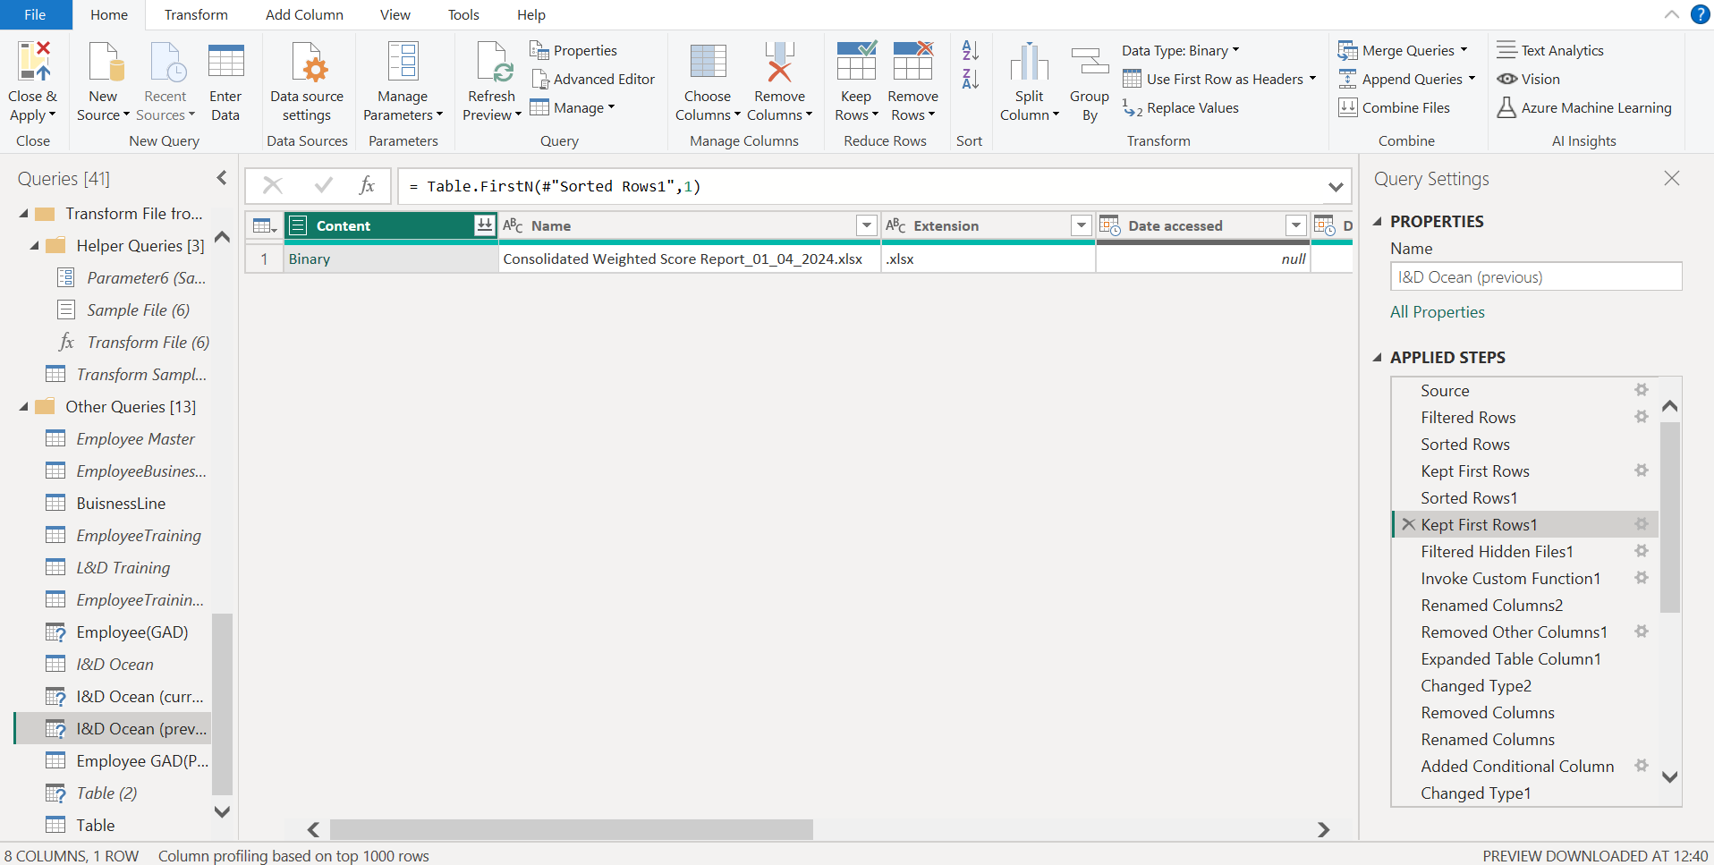

Similarly, these changes need to be applied every month to keep the dashboards updated.

**Dashboard**

